**Apartments in new housing projects in the first half of 2025**

**Analysis of apartment transactions in the new housing projects in Riga**

Activity in the new housing project market increased overall in 2025 compared to 2024, with the number of transactions in the first half of this year 31% higher than in the second half of last year. In turn, compared to the first half of 2024, the number of transactions this year is 46% higher. This year, the number of transactions in the first half of the year was higher than in the second half of 2024 both in Riga's housing estates (+36%) and in the centre of Riga (+7%).

**Breakdown of number of apartment transactions in the new housing projects in Riga, 2023 – 2025**

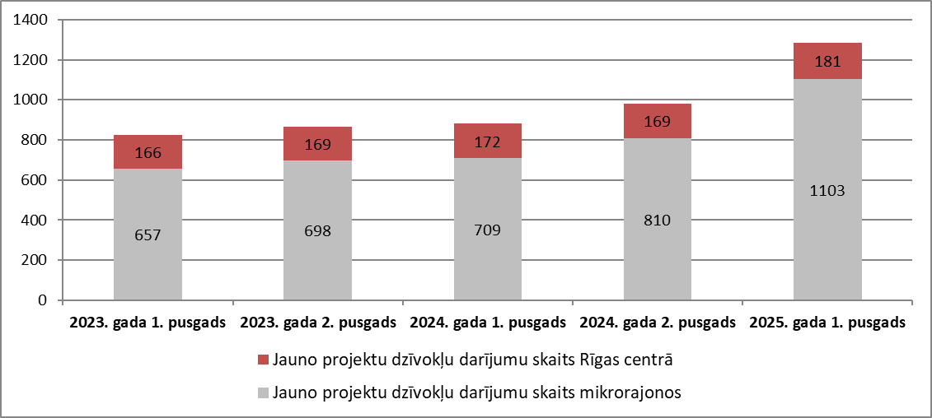

*Source: STATE LAND SERVICE, ARCO REAL ESTATE*

Looking at the number of transactions involving apartments in new projects in Riga in 2025, it can be concluded that most transactions (42%) took place in the price range of EUR 100,000 to EUR 150,000. In this price range, 90% of transactions were registered in Riga's housing estates.

**Breakdown of number of apartment transactions in the new housing projects in Riga in the first half of 2025 by price ranges, EUR**

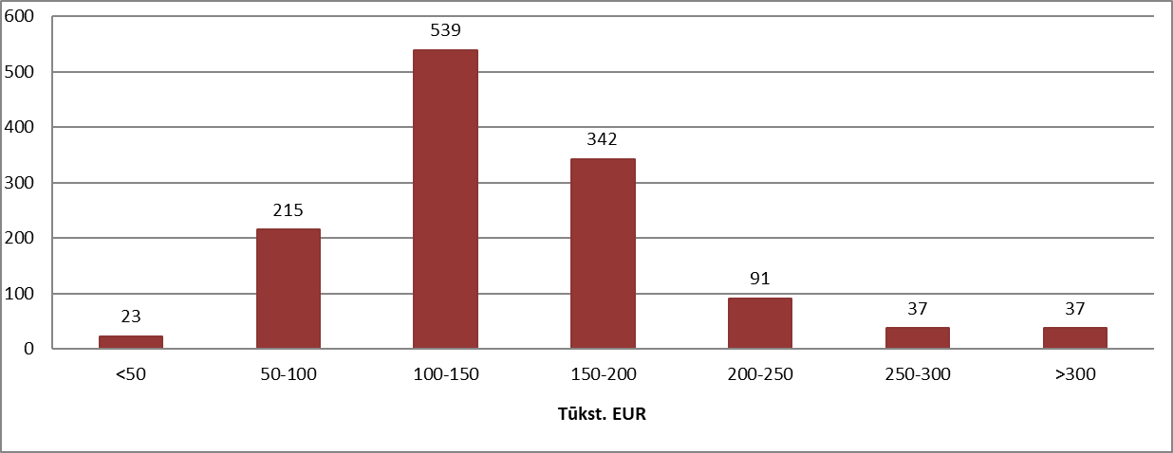

*Source: STATE LAND SERVICE*

In the centre of Riga, most transactions were registered in the price range from EUR 100,000 to EUR 150,000. These were mostly (56%) two-room apartments, both in buildings constructed at the beginning of the 21st century and in newly built buildings constructed in recent years. In this price category, most transactions were recorded in the newly built apartment building project *Ģertrūdes kvartāls*, located at 65 Ģertrūdes Street in Riga, where small (39-61 m2) apartments (mostly two-room) were sold. As a result, the price per square meter of apartments in this project exceeded 3,000 EUR/m2.

In Riga's housing estates, most transactions were also registered in the price range from EUR 100,000 to EUR 150,000. In this price category, most transactions took place in the newly built apartment project *Mārpagalmi*, located at 15 Zemaišu Street in Riga.

**Breakdown of the number of apartment transactions in new projects in the centre of Riga and housing estates by price ranges in the first half of 2025, EUR**

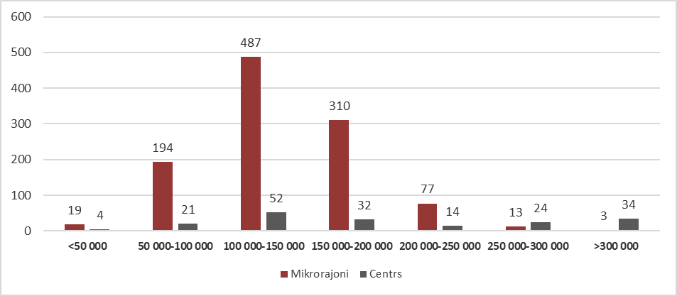

*Source: STATE LAND SERVICE*

Compared to the end of 2024, the supply of new apartments in Riga's largest housing estates and the city centre was less than 4% in the middle of this year. The supply of new apartments decreased in Riga's housing estates by 5%. In contrast, the supply in the centre of Riga was less than 1% lower than at the end of 2024. In June, the supply of new projects was also lower than in the middle of the previous year.

**Breakdown of the number of new project apartments offered for sale in Riga**

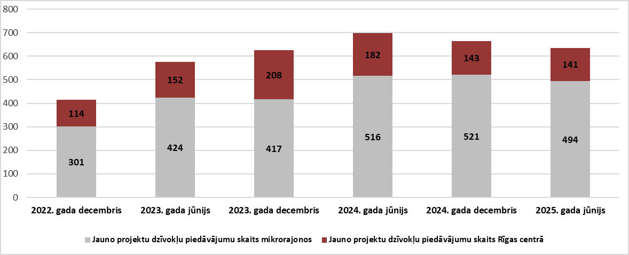

*Source: ARCO REAL ESTATE*

Overall, there were around 640 apartments on offer in new projects in Riga in mid-2025 (700 in mid-2024). The average price of apartments was EUR 2,396/m2, which was 4% higher than in mid-2024 and at the end of 2024. The average price of apartments in Riga's housing estates in mid-2025 was EUR 2,226/m2, while in the city centre the average price reached 2,988 EUR/m2.

**The average price of new project apartments offered for sale, EUR/m2**

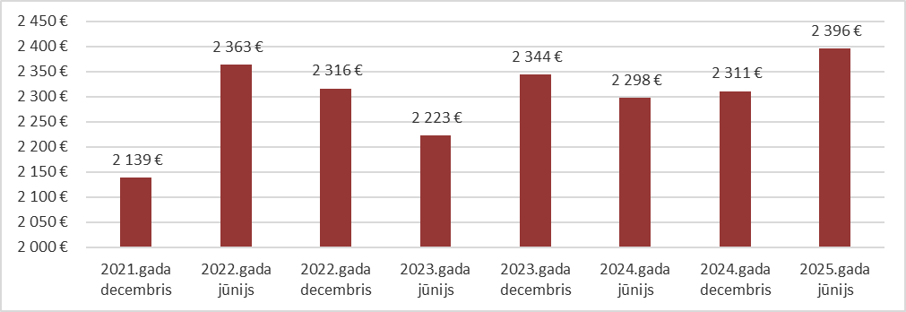

*Source: ARCO REAL ESTATE*

**New housing project apartment market in Riga housing estates**

The average price of apartments in new projects in Riga's housing estates reached EUR 2,212/m² in mid-2025. This means that apartment prices were 4% higher than at the end of 2024. Compared to the second quarter of 2024, the average price of apartment transactions in mid-2025 was 3% higher. Thus, it can be concluded that, unlike the Soviet-era mass-produced apartment market, where prices have remained fairly stagnant, this year has seen an increase in apartment prices in the new project segment. Since the beginning of 2021, apartment prices in new projects in Riga's housing estates have risen by41 %.

**Price dynamics of new housing project apartments in Riga housing estates, EUR/m²**

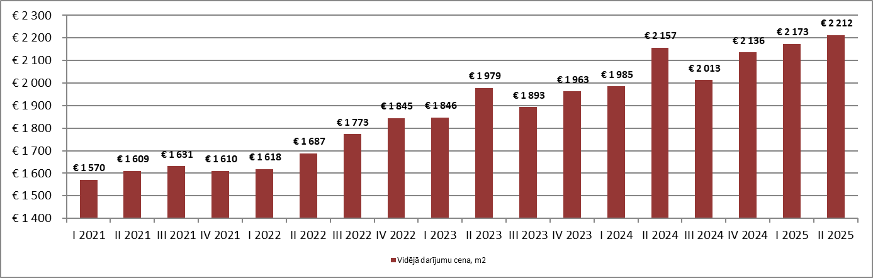

*Source: ARCO REAL ESTATE*

In the first half of 2025, a significant increase in activity was observed in the new project segment in Riga's housing districts. This year, there were 36% more transactions than in the second half of 2024 and 56% more transactions than in the first half of 2024.

**Dynamics of number of apartment transactions in the new housing projects in Riga housing estates**

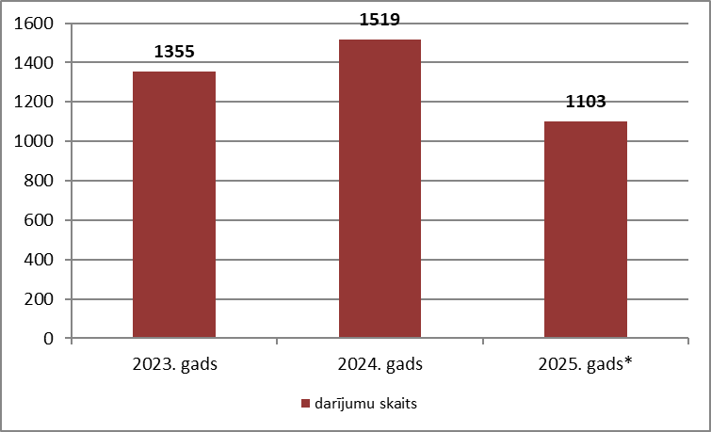

*Source: STATE LAND SERVICE*

* 1st half of 2025

The highest number of apartment transactions in 2025 was recorded in the first quarter, and the number of transactions was the highest in recent years. A smaller number of transactions were registered in the second quarter, but this figure also exceeded the quarterly figures for previous years.

**Dynamics of number of apartment transactions in the new housing projects in Riga housing estates**

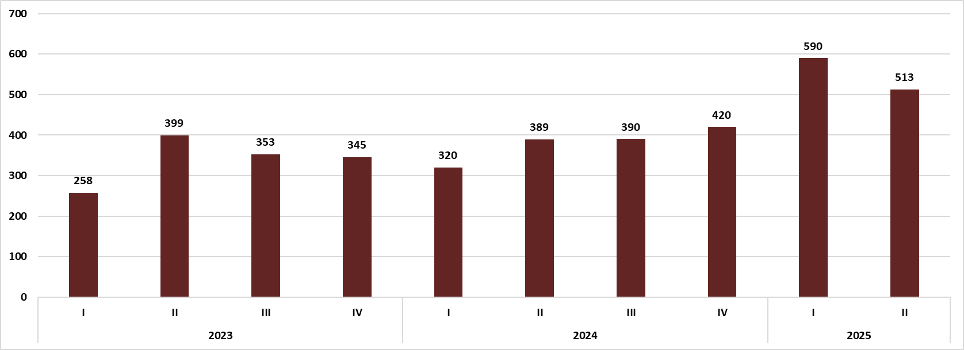

*Source: STATE LAND SERVICE*

In 2025, the typical price for new projects in Riga's housing estates ranged from EUR 2,200 to EUR 2,600 per square meter. According to data from the State Land Service, 34% of apartment transactions were registered in this price range. For comparison: in 2024, most apartment transactions were registered in the price range of EUR 2,000 to EUR 2,600 per square meter, while in 2023, they were registered in the price range of EUR 2,200 to EUR 2,400 per square meter.

**Breakdown of number of transactions by square metre price ranges in the new housing projects in Riga housing estates**

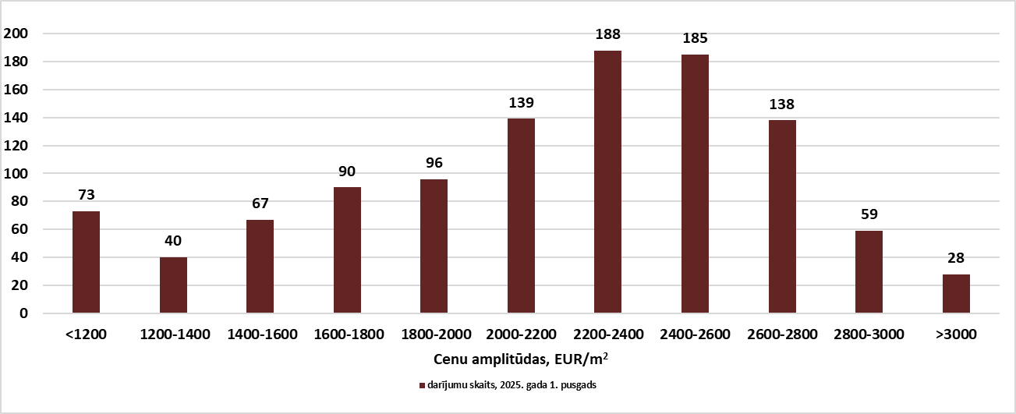

*Source: STATE LAND SERVICE*

In the first half of 2025, most transactions involving new apartments in Riga's housing estates took place in the price range of EUR 2,200 to EUR 2,400 per square meter. Such transactions accounted for 17% of the total number of transactions. Most transactions in this price category took place in the newly built apartment complex *Mārpagalmi*, located at 15 Zemaišu Street in Riga. Transactions in this project mainly involved two- and three-room apartments (average apartment size – 58 m²).

In the first half of 2025, 17% of transactions in new projects in Riga's housing estates were also registered in the price range of EUR 2,400 to EUR 2,600 per square meter. In this price category, most transactions also took place in the newly built apartment complex *Mārpagalmi*. The average price of transactions in this project was EUR 2,482/m².

In 2024, 15% of new apartment projects in housing estates exceeded EUR 2,600/m². In the first half of 2025, 20% of apartment transactions had already exceeded this threshold. Thirteen percent of transactions were registered in the price range of EUR 2,600 to EUR 2,800 per square meter. Most transactions at this price level were registered in the new project in Riga, at 16 Ropažu Street. The most expensive transactions in this project reached EUR 3,000 per square meter.

The most expensive apartments in Riga's housing estates exceeded EUR 3,000 per square meter, and the number of such transactions was similar to the previous year – around 3%. Most transactions at such a high price per square meter were registered in the new apartment project *Moho Garden*, located at 6 Mežezera Street in Riga. Prices in this project reached EUR 3,400/m². The average area of apartments in transactions in this project was around 60 m², with two- and three-room apartments dominating the transactions.

The most expensive transaction in a new project in a Riga housing estate in the first half of 2025 was recorded in the new apartment building project *Moho Garden*, located in Riga, on Mirdzas Ķempes Street, at almost EUR 3,500/m².

Approximately 7% of apartment transactions were registered at up to EUR 1,200/m². The proportion of such transactions decreased compared to 2024. Many of these transactions involved apartments whose recorded prices most likely did not fully reflect the total transaction amount. Apartments in new or completely renovated buildings are rarely offered at prices below EUR 1,200/m². These are usually illiquid, large apartments with poor locations in buildings, impractical layouts, and other negative factors.

Analysing the proportion of transactions by number of rooms in an apartment, it can be concluded that in 2025, almost half of the transactions in Riga's housing estates involved two-room apartments (44%). The proportion of two-room apartments was similar to previous years. Comparatively fewer transactions were made with three-room (37%) and four-room apartments (10%). In turn, the fewest transactions were registered with one-room apartments (8 %).

**Number of transactions with apartments in new housing projects in Riga housing estates in the first half of 2025 (breakdown by number of rooms in apartment)**

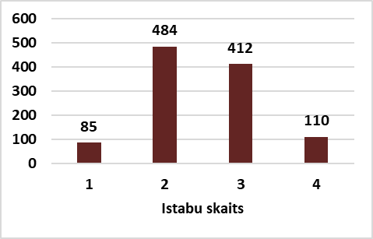

*Source: STATE LAND SERVICE*

An analysis of apartment transactions in new projects in Riga's housing estates by total area shows that, as in previous years, most transactions involved apartments of average size. In the first half of 2025, the most sold apartments were between 50 and 85 m2 (634 transactions or 57% of the total number of apartment transactions in new projects in Riga's housing estates). There were significantly fewer transactions involving small apartments ranging from 35 m2 to 50 m2, and even fewer involving large apartments over 85 m2. The fewest transactions involved small apartments up to 35 m2 (35 transactions).

**Number of transactions with apartments in new housing projects in Riga housing estates in the first half of 2025 (breakdown by total area)**

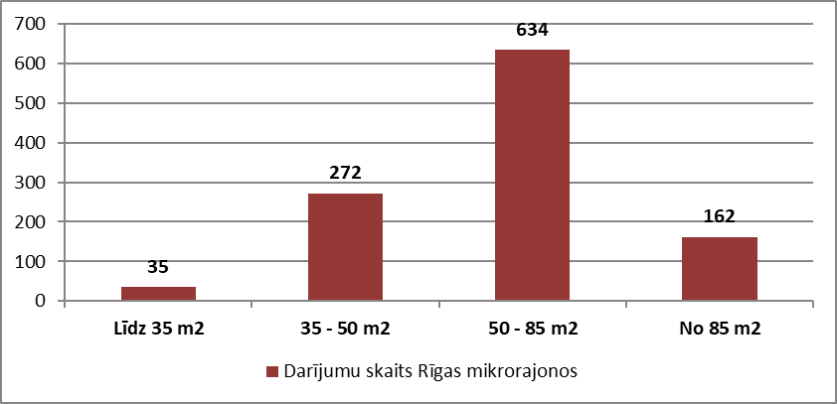

*Source: STATE LAND SERVICE*

**Supply of new housing projects in housing estates of Riga**

Summarizing the number of offers, it was found that the largest number of new project apartments in mid-2025 was in Āgenskalns (at the end of 2024 – in Teika). The number of apartments offered in new projects in Āgenskalns increased by 24% this year. In Vecmīlgrāvis, however, no new projects were found in mid-2025. Compared to the end of 2024, the number of apartments on offer in Riga's largest housing estates fell by 2 %.

**Supply of new project apartments in Riga housing estates, July 2025**

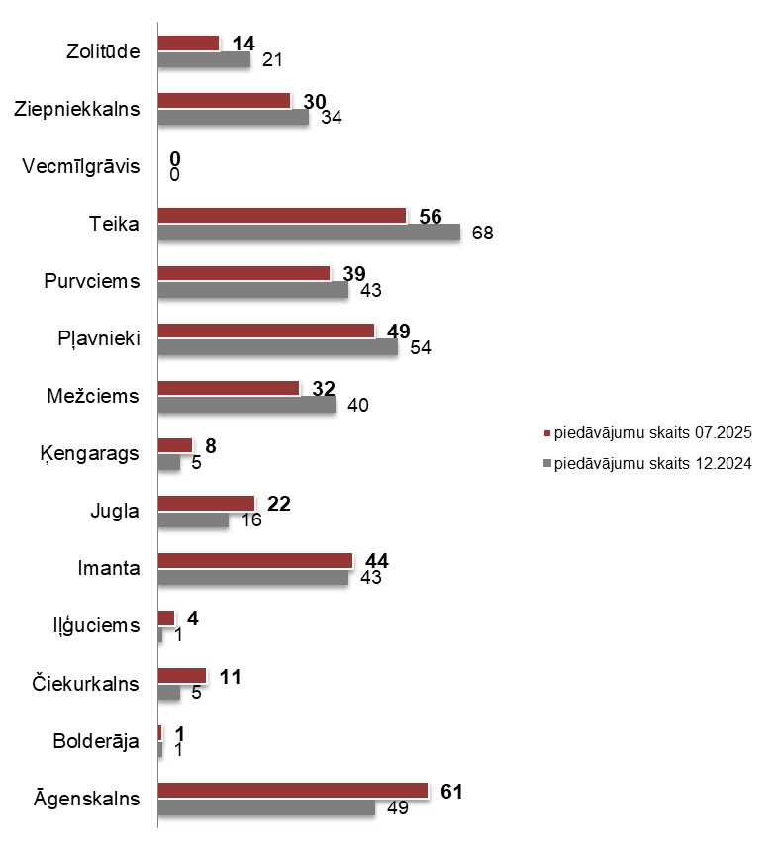

*Source: ARCO REAL ESTATE*

**New housing project apartment market in the centre of Riga**

In the centre of Riga, as well as in districts close to the centre such as Ķīpsala and Klīversala, the average price of new projects in mid-2025 was EUR 2,617/m². The average price was 3% lower than at the end of 2024. However, compared to the second quarter of 2024, the average price of new project apartments in the centre of Riga in the second quarter of this year was 7% higher.

**Dynamics of new housing project apartment prices in the centre of Riga, EUR/m²**

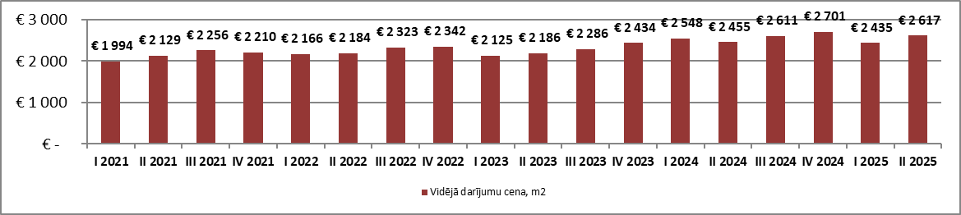

*Source: ARCO REAL ESTATE*

In 2025, a slight increase in the number of transactions was observed in the new project segment in the centre of Riga and in districts close to the centre, such as Ķīpsala and Klīversala. This year, there were 7% more transactions than in the second half of 2024 and 5% more than in the first half of the year.

**Dynamics of the number of transactions with apartments in new housing projects in the centre of Riga**

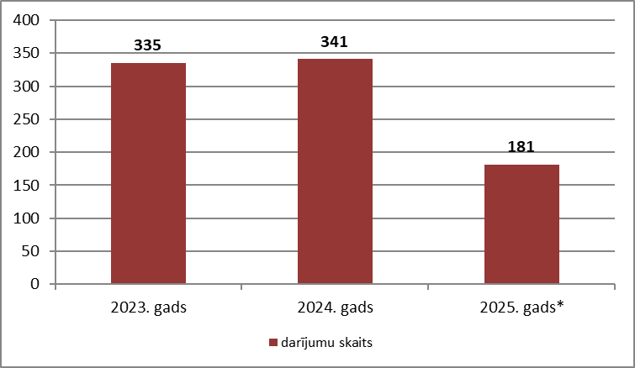

*Source: STATE LAND SERVICE*

* 1st half of 2025

In terms of the number of transactions, the second quarter of 2025 was the most active, with 106 transactions in new projects in central Riga. Fewer transactions were recorded in the first quarter, but a low number of transactions in the first quarter of the year was also typical in previous years.

**Dynamics of the number of transactions with apartments in new housing projects in the centre of Riga**

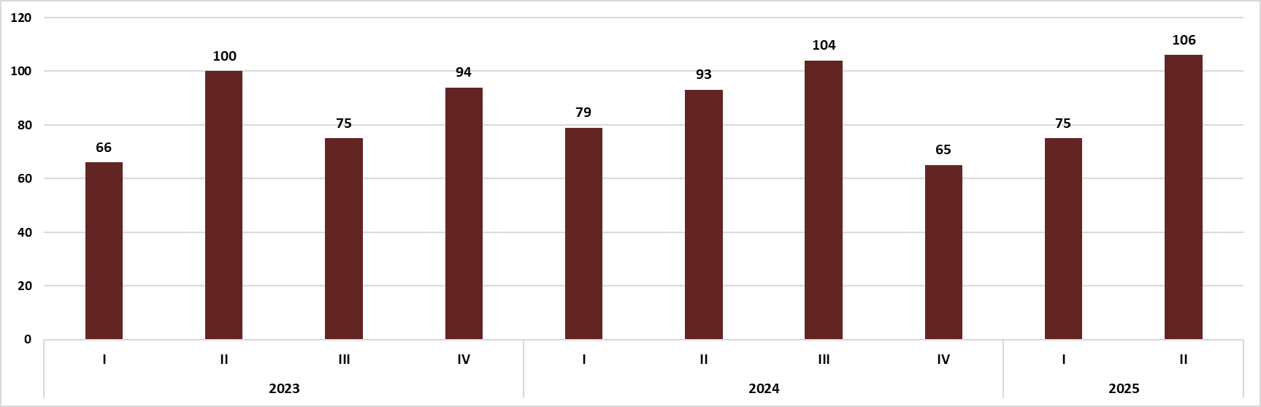

*Source: STATE LAND SERVICE*

In 2025, apartment transactions were still being recorded at prices below EUR 1,400/m² (10% of the total number), which is not typical for central Riga. Most likely, these transactions did not reflect the total transaction amount. It should be noted that the proportion of these transactions is similar to the previous year (in 2024, it was 8% of the total number of transactions).

The typical price range for new projects in central Riga in 2025 ranged from EUR 1,800 to EUR 3,000 per square meter. More than half (55%) of transactions took place in the most typical price range for central Riga. In 2025, the most common transactions were recorded in the price range from EUR 2,200 to EUR 2,600 per square meter and from EUR 2,600 to EUR 3,000 per square meter (in 2024, most transactions took place in the price category from EUR 2,200 to EUR 2,600 per square meter). In the price range from EUR 2,200 to EUR 2,600 per square meter, most transactions were registered in the new project *Ģertrūdes kvartāls*, located at 65 Ģertrūdes Street in Riga, as well as in other buildings constructed in the first decades of the 21st century. A relatively large number of transactions in this price category were registered in new buildings in the Skanstes neighbourhood and on the outskirts of the city centre. An equal number of transactions (the second most popular price category in 2025) took place in the range from EUR 2,600 to EUR 3,000 per square meter. This price range accounted for 19% of all apartment transactions in the city centre. The most popular project in this price range was a building constructed in the first decade of the 21st century at 20A Ernesta Birznieka Upīša Street. The average transaction price for this project was EUR 2,791/m².

There were also relatively many transactions in the price range from EUR 3,000 to EUR 3,400 per square meter. In this price category, most transactions involved apartments in the newly built *Merks* project *Viesturdārzs*. Overall, this price range accounted for 12% of all transactions involving apartments in new projects in the city centre.

The number of transactions involving expensive and exclusive apartments in new projects in central Riga in 2025 is similar to that of the previous year. Only six transactions were registered in the first half of 2025 at prices above EUR 4,000/m². For comparison: six such transactions were also registered in the first half of 2024. The most expensive transaction in new projects in the city centre was registered in the “near centre” of Riga, at 11 Lāčplēša Street, at almost EUR 5,400/m².

**Number of new projects in central Riga by square meter price range in the first half of 2025**

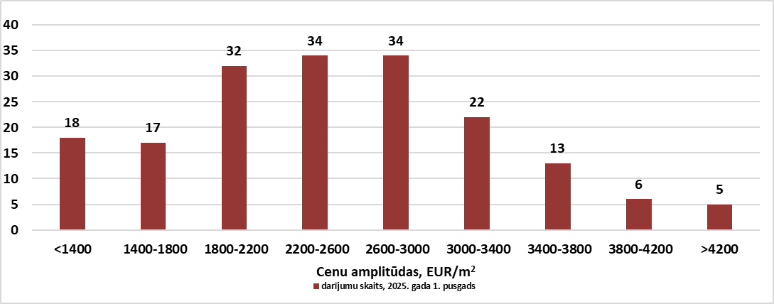

*Source: STATE LAND SERVICE*

In 2023 and 2024, there were significantly more transactions involving two-room apartments in the centre of Riga. In the first half of 2025, however, a relatively large number of transactions in the centre of Riga also involved three-room apartments (33%). Comparatively fewer transactions involved one-room apartments (17%). Four-room apartments were the least popular, accounting for 11% of the total number of apartments sold in the city centre. Two-room apartments in new projects in the centre of Riga have been the most popular for the seventh year in a row.

**Breakdown of new project transactions in central Riga by number of rooms in an apartment in the first half of 2025**

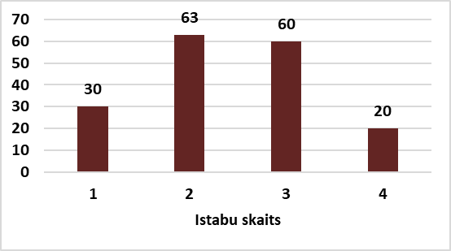

*Source: STATE LAND SERVICE*

Similar to previous years, apartments ranging from 50 to 85 m2 in size were the most popular in the city centre this year (43% of new apartment transactions in the city centre). Analysing apartment transactions in new projects in the centre of Riga by total area, in the first half of 2025, most transactions involved medium and large apartments. During the first half of the year, a relatively large number of apartment transactions were also registered for apartments larger than 85 m2 (40% of new apartment transactions in central Riga). Significantly fewer transactions in the centre involved apartments with an area of 35 to 50 m2 (20 transactions or 11% of new apartment transactions in central Riga). Apartments with an area of up to 35 m2 were sold the least frequently, accounting for only 6% of the total number of apartments sold in new buildings.

The number of transactions involving exclusive large apartments (over 200 m2) in 2025 was similar to previous years. Eight such transactions were registered in the first half of the year. Between 2022 and 2024, 7-9 such transactions were registered each year.

**Breakdown of new project transactions in central Riga by total area in the first half of 2025**

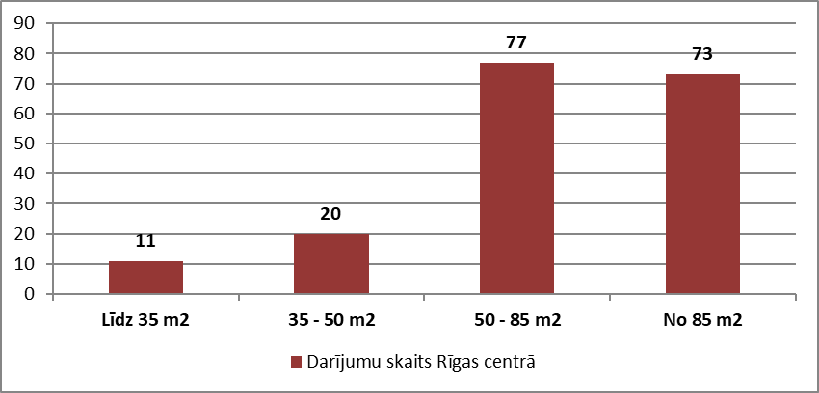

*Source: STATE LAND SERVICE*

**Supply of apartments in new housing projects in the centre of Riga**

In mid-2025, there were around 140 new apartment projects on offer in the centre of Riga and in districts close to the centre, such as Ķīpsala and Klīversala. Compared to the end of 2024, the volume of supply is roughly similar. In July, Klīversala had the fewest apartments on offer in central Riga. There were also relatively few new projects on offer in Vecrīga and Ķīpsala, but their number was slightly higher than at the end of 2024.

**Supply of apartments in new housing projects in the centre of Riga, July 2025**

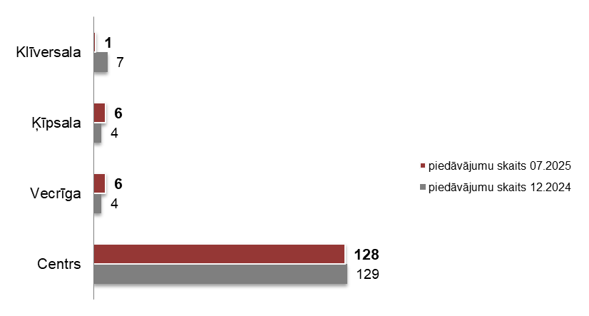

*Source: ARCO REAL ESTATE*